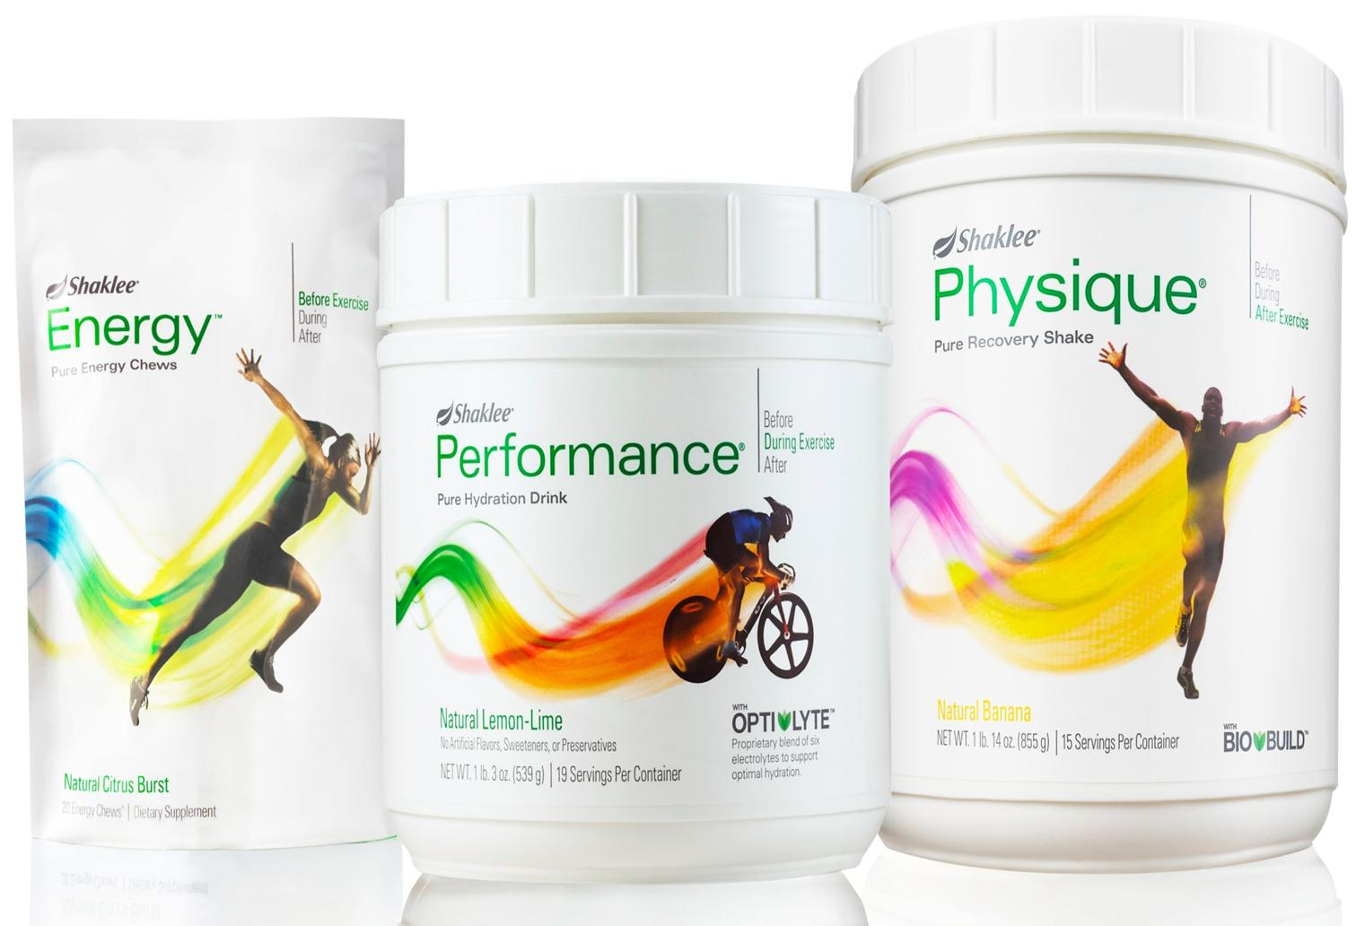
SHAKLEE PHYSIQUE

Muscle Strength and Recovery

One important ingredient necessary to aid in muscle retention/recovery or building is a broad-spectrum natural protein supplement that will provide the body with the needed building blocks to increase strength and muscle size without risking an excessive amount of any single amino acid. Nutritional experts prefer complete protein supplements which supply all of the essential amino acids in concentrated form.

Shaklee’s Muscle “Strength and Recovery” drink was specifically designed as a Sports Nutrition Product to maximize training efforts.
- It is a healthy, drug-free way to build lean muscle mass
- It helps you to recover more quickly from a workout
- It is designed to stimulate your own natural, anabolic muscle-building/retention process
- It gives a faster energy return, so you can maintain a more strenuous workout
- If you are working hard for body building or strength, it creates OPTIMAL conditions for maximum muscle mass and strength development.
Even though this phenomenal product was designed for athletes, it is useful to anyone who has a desire to maintain excellent muscle strength, mass and tone (see end notes on the benefits to senior citizens).

To better understand the product, let’s review how muscle strength and mass are formed.
- When you work a muscle hard, you actually break down muscle tissue. This is called a “catabolic state”.
- The muscle then rebuilds itself larger and stronger than it was before. This building stage is called the “anabolic state”.
- After a workout your body needs to rebuild and restore energy to torn-down, exhausted muscles. With the right nutrition at the right time you can help accelerate and maximize this process.
- Research shows that what an athlete consumes AFTER A WORKOUT may be as important to muscle building as the workout itself.

Wouldn’t it be nice to be able to move the anabolic, or building and recovering stage of muscle into high gear without the use of steroids or other drugs (that have
unpleasant short-term and dangerous long-term effects). That is exactly what Shaklee Physique does. Taking Physique immediately after a workout and then 2 hours later helps athletes of all skill levels and anyone who

requires muscle repair to experience recovery, muscle gain, and restored muscle energy.

How to use Physique
- Finish each workout with a serving of Physique.
- Drink a second serving two hours later
- For really intense workouts or for weight gain, users should have a third serving at bedtime.
Physique can be used in conjunction with any strenuous exercise, but it will help to build muscles the best when used in a program of weight training combined with aerobic exercise.

What does it contain? Physique contains a unique protein and carbohydrate blend called Bio-Build. This is a precise formulation specifically designed to increase the anabolic hormone in your body for an enhanced body-building state. Once the anabolic state has shifted into high gear, the Bio-Build of Physique is designed to feed your muscles easily available glucose and amino acids needed for three things:
- Rebuild muscle stronger
- Increase muscle mass
- Restore energy to fatigued muscles

Physique is a banana-flavored powder that can be mixed with water, juice or milk to form a DELICIOUS low-fat, nutritious drink to repair muscles after workout. It contains high-quality milk protein and whey protein isolates: it has a Protein Efficiency Rating (PER) of 3.0, equivalent to casein or milk protein, making it excellent for the repair or building of muscle tissue. These proteins are particularly good sources of the branched-chain amino acids, valine, leucine, and isoleucine, which are present in a relatively high percentage in muscle fibre protein. Physique does not contain individual or “free-form” amino acids such as L-tryptophan – it contains only whole proteins with their naturally-occurring amino acids.

Although it is formulated with whey protein and milk protein isolates, Physique contains no milk sugar. As a result, when mixed with water or juice, Physique is lactose-free.

Physique is also low in fat – when made with water, juice or skim milk, it contains less than 1 gram of fat per serving.

To ensure that it stays fresh, Physique contains the “ShakleeGuard” antioxidant system … a blend of ascorbyl palmitate, mixed tocopherols and rosemary extract that helps prevent the oxidation of sensitive ingredients. It contains no artificial sweeteners or flavours, and most importantly, clinical testing has shown it really works.

Clinical Test Results
In one of the clinical studies, nine elite cyclists rode to exhaustion with an alternating workload that reflected race-like conditions. After the ride they were given one of three drinks:
- Physique
- A carbohydrate-only drink
- A protein-only drink
The results confirmed that the carbohydrate-protein combination of Physique elicited a greater insulin response in the blood than the carbohydrate or protein supplements alone.

The study also measured each athlete’s muscle glycogen level … the body’s store of carbohydrate. The Physique drinkers clearly came out ahead of those who had both other drinks. In fact, the carbohydrate-protein combination of Physique proved to be so effective that it was patented by Shaklee under the name Bio-Build. Its unique carbohydrate-to-protein ratio does two things:
- It helps the pancreas to produce more insulin after exercise than either protein or carbohydrate alone
- It also helps to control blood glucose levels so there aren’t peaks and valleys in energy level.
Increased insulin production puts the body into an anabolic, or tissue-growing state. Insulin b\drives the branched-chain amino acids and glucose into the cells to increase lean muscle building and restore strength.

Other Recommendations:
The proper absorption of protein is very complicated and can be influenced by several factors. Enzymes are essential for protein absorption, so a diet including enzyme-rich raw fruits and vegetables is important. It is also recommended that the athlete provide a “guaranteed” source of all essential vitamins and minerals by taking Shaklee’s Multiple Vitamin/Mineral Supplement – Vita-Lea.

Shaklee’s Glucose Regulation Complex is recommended along with Physique immediately after a workout. The ingredients, especially chromium, spark the anabolic state immediately after work.

Another substance which can assist in the proper absorption of protein is lecithin.

Physique ….. Highly Recommended for Seniors
The following report comes from Dr. Richard Brouse, Sunnyside Health Center and Chiropractic Clinic in Clackamas, Oregon:

“As you know, the nutritional needs of mature individuals is unique.
- Digestion, muscle mass and hormonal regulation tend to decrease.
- Body fat and blood cholesterol levels tend to increase.
- Cardiovascular efficiency, blood sugar regulation and energy levels tend to decrease.
These changes seem to be related to the aging process and made us ask the question …. ‘What factor seems to have the greatest effect on aging?’

After two years of recommending Physique to 210 elderly patients (men and women between 65 and 84) at this clinic, we noticed some amazing results that we would like to share with you …..
- 72% of people over 65 years of age who began using Physique daily had an increase in energy and more muscle mass after six months
- Sugar regulation I those who had been hypoglycemic or hyperglycemic returned to normal in 56% of the cases within 3 months after starting daily use of Physique
- 60% of all elderly patients following our recommended exercises had less muscle and joint symptoms within 3 months after daily use of Physique.
These findings can only suggest that Shaklee Physique is a very useful addition to the nutritional program of the elderly population who are physically active and taking positive steps to maintain their health. When maximizing the diet and regularly supplementing, significant benefits can be gained by the elderly using Physique.

We are very excited about these findings and hope that mature people and not just yong people will take advantage of this outstanding product.”

Others who would Benefit for Physique:
ANYONE suffering from muscle fatigue would benefit immensely from the daily use of Physique
- people who suffer with fibromyalgia,
- people who suffer with chronic fatigue syndrome
- builders
- anyone whose work makes heavy physical demands on the muscles
- etc.

FOR MORE INFORMATION CONTACT:

